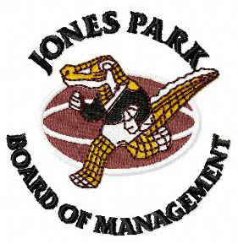
CONDITIONS OF USE

Breaches of these conditions of use may result in cancellation of access.

(1) ALCOHOL:

No alcohol is to be taken into Jones Park. All alcohol consumed on the premises must be purchased through the JPBM. The JPBM reserves the right to insist the patrons and such items be removed from the premises.

(2) GLASS:

No glass bottles or containers are to be taken into Jones Park. This is a safety issue and will be strictly enforced.

(3) SMOKING:

The Jones Park environs are a “Smoke Free Area”. This policy will be strictly enforced and patrons not complying may be asked to leave the premises.

(4) DOGS/OTHER ANIMALS:
Dogs and other animals are not permitted in any area of the facility including fields. This is a health and safety issue. Non-compliance will result in the calling of the Cairns Regional Council Local Laws Officer.

(5) VEHICLES:

No vehicle access is permitted within the general field area of Jones Park with the exception of authorized vehicles. Patrons are to use the Car Park provided.

(6) SKATEBOARDS/BICYCLES/SCOOTERS/ROLLERS:

Skateboards and bicycles are not to be taken into the Park. Non-complying patrons may be removed from the premises.

(7) RAFFLES/SALES:

Any raffles and sale of any items are not permitted without the express permission of the Board/FMO. Hawkers and non-authorised individuals will be removed from the premises.

(8) RUBBISH:

The User accepts responsibility for the collection of all rubbish during the periods of use by them. Such rubbish must be placed in the industrial bins provided. Non-compliance may mean the forfeiture of any Bond or part thereof.

(9) UNAVAILABILTY OF USE:

The Groundsman in conjunction with his Responsible Director will be the sole arbiters and will exercise the powers of the Board if the fields are deemed to be unplayable or use poses a long-term threat to their condition.

(10) KEYS:

Users will be provided with keys to access their rightful usage. A Bond may be levied by the FMO to cover replacement in the event of loss.

(11) BEHAVIOUR:

The User will at all times assume responsibility for the behaviour of patrons attending as part of their Usage Agreement. This includes spectators. It is expected the User will deal with any issues. The FMO (possesses security qualifications) may be called upon to assist
if necessary.

(12) ADVERTISING OF FACILITY:

The user agrees to consult the FMO regarding any advertising of the facility to ensure it is not detrimental to the image of the facility.

(13) PROMOTION OF FACILITY:

The user agrees to promote use of the facility in any material issued as part of their User Agreement. All media statements must also positively identify the venue.

Last Amended 30 June 2018

