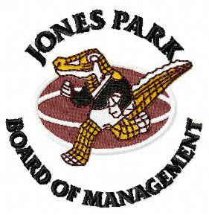

CONDITION OF ENTRY

It is a condition of entry to Jones Park that all patrons will permit inspection of bags, backpacks, prams, trolleys and any esky, box or other container when requested.

Failure to do so will result in refusal of entry.

By Order
The Board JPBM

